Ryan Coyne

Kathryn Garner, Crystal Juarbe

BIO L411-11

9/28/2023

Chemotaxis of *C. elegans* in Response to Melatonin

**Introduction**

*Caenorhabditis elegans* is a transparent species of nematode which is often used in research because they have a short life and therefore will quickly become adults. Chemotaxis refers to the movement of an organism in response to a chemical stimulus. *C. elegans* is able to detect many chemicals in its environment and has a simple nervous system which responses to sensory inputs. The nervous system is composed of 473 cells for males and 358 cells for others (Hall et al. 2005).

Prior to conducting this experiment *C. elegans* were observed to be attracted to a solution of Wilton’s butter. They were placed on an agar plate with water on one side and Wilton’s butter on the other and were observed to be on the side with Wilton’s butter much more frequently. This was contrasted against the result when water was placed on both sides of the plate and the *C. elegans* were not observed to have a significant preference for either side.

According to Niu et al. (2020) exposure to melatonin can induce a state called lethargus into *C. elegans*. This state is similar to sleep in mammals. If *C. elegans* are exposed to melatonin, then they will display a negative chemotaxis response. That is to say that we expect them to move away from the melatonin in aggregate, because if exposed to the melatonin they may become sluggish which would make acquiring food more difficult.

Experimental Design and Methods

Nine transparent plates of agar were marked on the underside with a circle in the center and a line through the center to divide the plates into two sections. On each side a dot was marked; one was labeled “A” and the other “B”. Next, on all plates, twenty microliters of water was pipetted onto the agar over the dot labeled “B”. On three of the plates twenty microliters of water was also pipetted onto the agar above dot “A”. This group is the negative control, to which the *C. elegans* were expected to have no reaction. On another three plates twenty microliters of Wilton’s butter solution was pipetted onto the agar above dot “A”. This group was the positive control, to which the *C. elegans* were expected to have a positive chemotaxis index, indicating it is a substance to which they are attracted. On the last three plates twenty microliters of melatonin was pipetted onto the agar above dot “A”. This was the experimental group. On each plate, two microliters of sodium azide solution was pipetted onto both dots. This is to paralyze the nematodes making them much easier to count. The temperature, light level, and air pressure in the room were controlled.

Twenty microliters of *C. elegans* were pipetted onto the agar above the circle that was drawn in the center of the plate. After thirty minutes passed, the plates were placed under a stereo microscope and the number of worms on each side was recorded. Any worms in the circle in the middle were not included in the counts. The dependent variable was the chemotaxis index, and the dependent variable was the chemical used to trigger a response. The chemotaxis index was calculated from the numbers of worms on each side by using the equation, $$\text{Chemotaxis index}=\frac{\text{\# of worms on side A}-\text{\# of worms on side B}}{\text{\#of worms on side A}+\text{\# of worms on side B}} .$$

Results

The chemotaxis response of *C. elegans* in response to melatonin was measured and compared against that of Wilton’s butter and water by comparing the measured chemotaxis index in response to each. The average chemotaxis index in response to the negative control, water, was $0.14±0.25$ (Table 1), which is within one standard deviation of the expected value of zero. In response to the positive control, Wilton’s butter, the chemotaxis index was $0.851±0.054$ (Table 1), which indicates that, as expected, they are attracted to the Wilton’s butter. The chemotaxis index of the experimental group in response to melatonin was $-0.36±0.14$ (Table 1), indicating that the *C. elegans* are inclined to move away from melatonin. The data is significant because the error in the measurements does not cause the negative and positive controls to overlap (Figure 1).

Table 1: Average chemotaxis index and standard deviation in response to Wilton’s butter, water and melatonin.

|  |  |  |
| --- | --- | --- |
|  | Average Chemotaxis Index | Standard Deviation |
| Water | 0.14 | 0.25 |
| Wilton’s Butter | 0.851 | 0.054 |
| Melatonin | -0.36 | 0.14 |

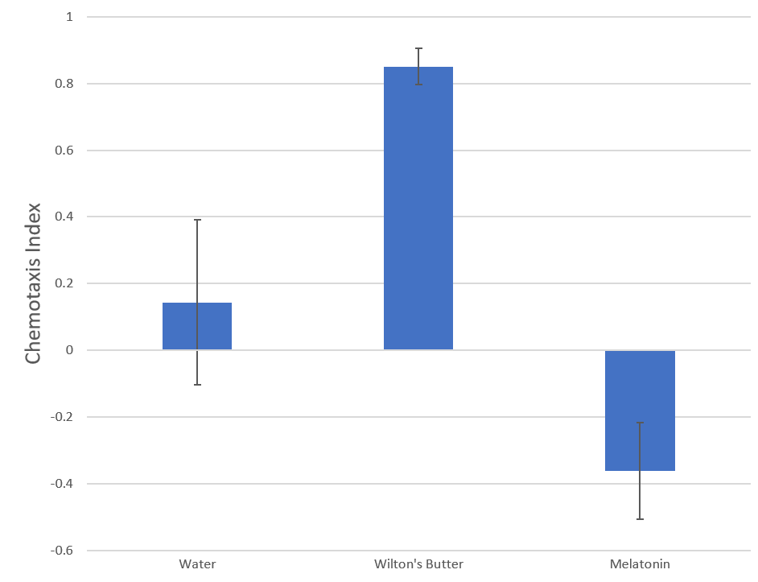

Figure 1: Average chemotaxis index in response to melatonin in comparison to Wilton’s butter and water.

Discussion

To determine the chemotaxis response of *C. elegans* in response to melatonin, the chemotaxis index was measured and compared to that of *C. elegans* in response to water, and Wilton’s butter. The hypothesis that *C. elegans* would be repelled by melatonin was supported by the data obtained. The negative chemotaxis index in response to melatonin indicates that the *C. elegans* prefer to move away from the melatonin. This contrasts with the positive chemotaxis index in response to the Wilton’s butter which indicates that they prefer to move toward the Wilton’s butter. The data was statistically significant because there is no overlap within the error of the control data. According to Niu et al. (2020) melatonin promotes a sleep-like state called lethargus in *C. elegans*. This may give insight into the way that it works in human beings which is not currently well understood.

While conducting the experiment, a small hole was poked into the agar on one of the experimental plates. If some worms had entered the hole, they may not have been counted which could have affected the results, but it doesn’t seem to have had a large impact since the results from that plate agree with the results from the other two plates in the experiment group. Next time a steadier hand would be useful in preventing this. Alternatively, a device could be created that allows the solution to be pipetted but does not allow the tip to touch the agar. There may have also been error derived from incorrect counts of the *C. elegans*. High resolution photos could be used to alleviate this because it is easier to count them when looking at a static image.

Melatonin is a sleep aid, and so in a sense it could be said that stimulants such as caffeine are its opposite. Additionally, caffeine promotes wakefulness and activity which is often desirable because it allows for additional opportunity to access food. If *C. elegans* are exposed to caffeine they may be attracted to it.

# Works Cited

Hall, D. H., Lints, R., & Altun, Z. (2005). Nematode Neurons: Anatomy and Anatomical Methods in Caenorhabditis elegans. *International Review of Neurobiology*, 1-35.

Niu, L., Li, Y., Zong, P., Shui, Y., Chen, B., & Wang, Z.-W. (2020). Melatonin promotes sleep by activating the BK channel in C.elegans. *Proceedings of the National Academy of Sciences*, 25128-25137.

Appendix

Measurements:

